NEWSLETTER

WHITE RIVER TOWNSHIP FIRE DEPARTMENT

VOLUME 13, ISSUE 4 April 23, 2004

Newsletter under new management …
At least for this month anyway! Chief Cassin has been so busy with the computers he didn’t realize that it’s already time for another newsletter. He sends his sincerest apologies and promises to issue the next one!

However, in the mean time….it’s all mine! So sit back, relax & enjoy!

☺ Kim

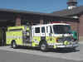

Apparatus Issues

How long have we been saying “Engine 51 is almost a reality”??? Well, I know you’ll all be shocked but we’ve run into more delays. Don’t panic…it’s nothing insurmountable. There just seems to be some confusion as to what the next step is and who has to take it. The truck is actually PHYSICALLY at Stoops Freightliner right now. Chief Cassin, Lt. Arkins & Joe Marsh have a meeting with their head sales person to find out exactly what is going on and when they’re going to release the truck to us. Hang in there just a little while longer Engine 54!!


Station Issues
The contract issues regarding the land at Olive Branch and 135 (Heron Ridge) for our next station have been resolved and we have paid $10,000 earnest money to the title company to purchase the land. A committee will be formed to help with plans for the building.



Training Issues

It’s still not too late to volunteer to help for FDIC. See Chief Thacker if interested.

REMEMBER: LET NO FIREFIGHTER SAY THEIR TRAINING FAILED THEM!



General Operations
Here is the status of the 2003 fire loan projects that are already under way. Here is a breakdown:

Hurst System: Trainings concluded and the system is in service.

AED’s: All fire department vehicles now
have one.

Computer system: Almost done!

Copier buyout: Project cancelled.

Chief Tibbetts has assumed control of the receptionist hiring process. He anticipates making a final decision on 4/26. I would like to personally thank everyone who either helped with interviews or sat in my office while we were out to lunch “just in case someone comes in”. Thanks A LOT!!!

Here is this month’s House Fund account summary: The breakdown is as follows:

Station 51: $2,628.28
Station 52: $1,956.61
Station 53: $1,648.27

- There was $201.74 in staple supplies for the month.

It is with regret that we announce Lieutenant Bruce Alexander has tendered his resignation so that he can further pursue his medical career. His last shift will be April 26. We wish him the absolute best of luck in his future endeavors and thank him for the hard work he has put in here. Good luck Bruce!!

The older thermal imaging camera has been placed on Rescue 51 and will be mounted as soon as the equipment arrives. The gas detector is also on R51. The newest thermal imaging camera is mounted in Aerial 53.

The new computer system is in the final phases of installation. Please be patient while Chief Cassin works out all the ‘bugs’ which are inherent in any new system, especially one the size of ours. Thanks to those who have been helping him set up the new computers, especially Mike Combs & Lt. Engmark, as well as Amy for doing a lot of the “behind the scenes” programming and setup. Thanks!!

On that same note, if you submitted a bid for one of the “old” systems, and have still not paid, please contact Chief Cassin immediately. You know who you are.

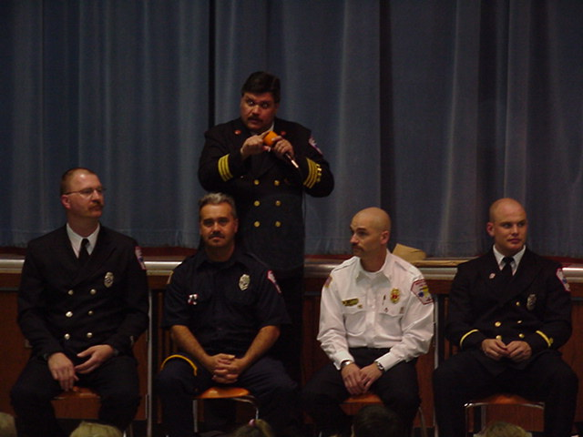

Health & Safety

There are many things going on around the department. To say that this spring has been, and will continue to be a busy time around here, is an understatement. Here are a hodge podge of things to let you know about.

- The new SOG on operating in vehicular traffic and/or the need to wear high visibility PPE is out. It is SOG #618. It is posted in all of the fire houses. All personnel shall become familiar with this SOG. If you have any questions about it, get with your officer or myself for clarification. Remember… Being seen out there is a good thing!

- We are progressing forward with purchasing new fire gear for all members. It will be a 2 step process that will take this year and next to complete. The members of the H & S Committee are currently working with the manufacturers and vendors out there to make sure that we get the very best protection at an affordable price for our people. The recent fire gear inspections will drive the priority list for who will get new gear this year vs. next year. More to come on this…

- All personnel should have received their new accountability tags. We change these annually for a few reasons. Over time, some people’s tags have gotten worn or damaged. Other folks have had some change in their information that is contained inside of the sealed tag. For these reasons and other, we’ll issue new tags on a yearly basis. If you lose or damage one of your tags, please e-mail me so a new one can be made ASAP. Remember, these tags are as required for you to use and maintain as any other piece of your PPE ensemble. Let’s remember to place them on the apparatus at the beginning of your shift and remove them at the end. Lately, there seems to be a little more “forgetfulness” in all of the stations with some personnel forgetting their tags at the end of the shift.

- Those of you that ordered an on-duty uniform golf shirt should have received it/them. They are in from the vendor. From the comments that have been received back, everyone seems very pleased with the way that they look and feel. We will be advertising another order very soon for those that may want to get some of these shirts.

- All personnel are reminded that if you experience any type of an injury while on-duty for this department, you must report it immediately. This must be documented and is for your protection. Please see the policy manual for what steps must be done for proper documentation.

- All members are reminded that as the warmer weather approaches, it is important to make sure that you are maintaining good levels of hydration. You should be drinking water throughout the shift, starting soon after you first arrive. It is much better for you to start out having a “full tank” then to try to play catch-up at an incident scene. Dehydration is a leading cause of fatigue and personnel injuries on emergency incident scenes. It can also contribute to making you be more susceptible to illness. Drink Up !!!

That’s all for now… Until next time, Let’s Be Careful Out There!!!


Notes from Kim ☺

For those of you with recent changes in family status (marriage, divorce, babies, etc.), please consider any paperwork changes that you may need to make. Beneficiaries, emergency contacts, tax information, etc.



Strawberry Festival

Meetings are now being held every two weeks at 6pm and still at Headquarters. The next one is April 22, then May 6, etc. All of those interested in helping plan the event are encouraged to attend. PLEASE!!! WE NEED HELP!

Be sure to check the Strawberry Festival web page in the employee section for planning information. This page is updated as the festival planning process continues.

Also, don’t be surprised when Chief Cassin begins asking everyone to donate some time to working the festival. Reminder, it’s June 11 & 12 at Pleasant Grove Elementary School. We had to move it this year due to road construction issues in front of Sugar Grove.



Auxiliary Corner

The Auxiliary’s next meeting is May 2nd at 5pm at fire headquarters. We are always looking for new members so anyone interested please feel free to attend!

Thanks to everyone who participated in our Easter Part and egg hunt on April 10th. It was a blast!

I said last month that our website would be changing soon and it still is. However, with the recent problems with the new computer system, the last thing I wanted to do was overload Chief Cassin with website problems. Therefore, watch for our “remodeled” web pages probably by the end of May. (I hope.)

Our web page still has a schedule for a list of meeting dates, upcoming events, recent photos, and information on the Auxiliary Program. www.wrtfd.org/auxiliary.htm. Our meetings are open to everyone so please feel free to attend and get an idea of the things we do!


Did you know……..

- Laptop computers and briefcases falling from the overhead bins onto passengers' heads may be the most common accident aboard an airplane. (Lookout Scott!)

- The sale of chewing gum is outlawed in Singapore because it is a means of "tainting an environment free of dirt." (Alrighty then.)

- The state of New York instituted the nation's first mandatory seat-belt law on July 12, 1984.

- ZIP code 12345 is assigned to General Electric in Schenectady, New York.

- The 2000 Oscar Mayer Wienermobile has a GMC W-series chassis and a 5700 VORTEC engine, which makes it the most powerful Wienermobile in the fleet. It measures 27 feet by 8 feet by 11 feet, or 55 hot dogs long, 18 hot dogs wide and 25 hot dogs high. (They have a fleet of those things?? How’d you like to be their mechanic??)



Did you Notice?

- The old Sonic restaurant/drive in is now a used car lot.

- Smokey Joe’s BBQ is now Smoke House BBQ. It seems there was too much confusion between Smokey Joe’s and Smokey Bones (US31 & Fry Rd).

- The Applebee’s being constructed at an alarming rate in front of Home Depot??



Birthdays

I think we’re a month behind somehow on the birthdays, so here are April & May birthdays!

April

3 – Jake Kocher

10 – Ed Carlson

13 – Mike Schilling

14 – Justin Cook

15 – Lisa White

15 – Sean Campbell

24 – Adam Whyde

30 – Rhonda Holtsclaw

May

4 – Don Young

5 – Ryan Cox

5 – Mike Boone

14 – Scott Wiegle

27 – Wayne Fletcher

29 – Chief Tibbetts

31 – Andy Cline



Looking Back…….

5 Years Ago……

April 21, 1999 | Training burns at SR 135 & Stones Crossing Road.
May 1, 1999 | Lawn mower at station 51 overfilled (by 1 gallon) with oil. Woops.
May 14, 1999 | Station 51 assisted public with baby ducks stuck in a culvert.
May 21, 1999 | Mock haz mat drill at North Grove Elem. School.
FYI ONLY | 1st Run # on 4/1/99 was 253.  1st Run # on 5/1/99 was 358.

- That’s it for this month – Be safe, Scott
Kim ☺

