Was it just me or did March seem to just zip by? Well, it’s April and spring has sprung and with that comes another somewhat lengthly newsletter. Sorry, that’s two months in row now.

Stations
As noted in last month’s newsletter, the weight room at Station 52 will be moved to the bay. However, the timing will now depend on when the mini “remodel” at Station 52 is complete. Now that I’ve mentioned that, I’ll expand that thought. We have been given the green light to make some minor
repairs and upgrades to the building. As you know, the project was started last fall, but was stopped due to budget constraints. Well, now it is time to move forward and finish the job. What you will see done, is some drywall repair, the whole station basically re-painted (a nicer color than our long-time favorite GRAY!) and NEW carpet and /or tile throughout (finally!!!!). So be prepared if you work at Station 52 as these projects could start at any time and your help and cooperation would be appreciated.

Well, like the newsletter says, it’s April and we all know what that means. It’s time to start mowing grass again. In fact, the lawnmowers were brought out of moth balls last week and mowing commenced. If you forgot, grass mowing is a Monday

duty unless it rains (all day) then it’s the next dry day. Be sure to note in the computer that you did it.
Apparatus
The new Tanker 52 and Rescue 51 are still on the assembly line and on schedule. We will be sending individuals down over the next several weeks for inspection and final retrieval of the apparatus. Once in, they will go get the graphics applied locally and then be returned to the stations for equipment placement and training.

Congratulations to Sean Atkinson and Lucas Graphman. Both have met the requirements to be promoted to Chauffeur on Engine 51. Also, Matt Ladd has been promoted to Chauffeur of Rescue 51. Congratulations Matt.

There are now disposable cameras on the engines. These are for official department business which may include pre-plans, inspections, training, and obviously incident investigation. Be sure to read the memo from Division Chief Brown regarding the use of these cameras.
Engine 51 has been added to the box alarm assignment to the Center Grove High School. This is as automatic aid to Bargersville Fire Department. Our responsibility upon arrival will be to support the sprinkler system which is accessed on the south side of the building by the loading docks. Bargersville will establish command and request any further assignments as needed.
Miscellaneous
After discussing the needs of the fire district as well as the capabilities of the department, it was decided that the department dedicate itself to becoming proficient in water rescue and specializing in this field. The Chief has given direction to the training division to head in this direction. As the department becomes more developed in this area, further equipment purchases will be made. Training has already begun with last week’s two day water rescue session. Attendance was good and the class was a real benefit for those who attended. There will be more training sessions in the upcoming months for those who could not attend.
Don’t forget the department-wide (although not department sponsored) camping trip next month on May 22, 23, and 24. It will take place at McCormick’s Creek State Park (about 40 minutes from here) and should be alot of fun. See Kim Clawson or Lori Roberts for details and to notify of your attendence. It occurs on “B, C, and A” shifts, in that order in case you were wondering.
Also mentioned last month was the project of updating the map books that Steve Rowland was working on. Well, he is done and the updated copies have been placed on each apparatus. Thanks again Steve!

I will be out of town (and country for that matter) from April 15th through April 26th. Direct any correspondence normally directed toward me to any other chief officer.

The next staff meeting is set for April 22nd and 23rd at 1300hrs at Station 51 both days in the conference room.

We have received our first check from the Build Indiana Fund in the amount of $125,000.00. The check will be turned over to the Fire Protection District Board at the April 7th meeting at which time a decision will be made as to how and under what circumstances the money will be used. The second check for $150,000.00 will be delivered soon and this will go toward the Station 53 project.

Effective April 1st, Captain Slauter will be splitting his average 100 hours worked per month. Part of the time will be spent as a paramedic on Engine 52 and the remaining portion will be spent on administering the safety programs which includes TB tests, HBV program, etc. He will also respond as the Safety Officer while in the office.

Joe Boggs and Jory Cox have been promoted to Assistant Cadet Advisors to help out Advisors Casey Arkins and Nick Alford to administer our highly successful Cadet Program. Congratulations Joe and Jory!

No new news on the house fund account. Still laying low after getting pinned down by Montgomery Ward last month.

No update on the “Permanent Station Committee”. The committee is still in progress.

The new MSA airpacks are in and on the apparatus. If you have not received your own mask as of yet, you need to get in and pick yours up. See the on-duty battalion ASAP. You will obviously need your mask to work. If you have not been to one of the trainings on the airpacks, again, see the on-duty battalion. I think you will be impressed with them. They are far superior to anything we’ve ever had before. Also, do not mark on the bags the masks come in (unless you would like to purchase your own) If you would like to ID your bag, you can purchase a tag similar to our PIC tags or use a piece of tape.

There will be times at Center Grove Middle School where the hydrants and/or FDC will be unavailable for our use. Pay close attention to any notices that may be posted regarding this issue. This is all due to the major renovation that is taking place and when done, should provide for four new hyrdrants as well as sprinkling of the whole building, and not just the stage.

Be sure to read the memo from Captain Slauter regarding the new turnout gear we are switching to and why. It is very informative and explains many important issues regarding safety.
FYI, I have given direction to our supply guy (Tom Arkins) to consolidate our EMS supplies into two locations. One at Station 51 (where they are now) and one at Station 52 (under the stairs that go to the equipment lock up). We will have a general supply of equipment (both ALS and BLS) to use should EMAS not be able to re-stock your unit. This should improve our accountability of EMS supplies. See below regarding the new addition to the EMS report.

Speaking of EMS supplies, when checking expiration dates on drugs, be sure to pull anything off TWO months before it’s expiration date. This is because we trade out with the hospital who could probably use the drug before it expires. (I know this is common sense, but it’s already happened: if you pull a drug off, be sure to replace it with a new one). The computer has been set up to remind you at the first of every month.
The ringdown feature on our phone system at both stations has been fixed by Ameritech. If a line is busy, the next call should “ringdown” automatically to the next available line.

Computer Update
Reports are looking pretty good this month with the exception of just a few. I am still seeing some of the same mistakes though. Basically there are just three big ones. They are as follows:
1) Be sure to add “M51” to all responses when appropriate. Some of us are forgetting them on EMS calls.
2) Always verify your hours worked, hours paid, and points are correct BEFORE adding a group of people. It only takes a brief moment to double check.
3) Be sure to “blank out” or put a “0” in the “temperature” field when putting in vitals.

Here’s what’s new this month: You will notice at the very end of the EMS report a new field called “Equipment NOT replaced by the ambulance”. It is on the same page where you put the meds and allergies. What this is, is a place to enter the equipment you used on the run that you could NOT get replaced by the ambulance crew for whatever reason. For example, you used an endolock on an arrest out of the kit on Engine 52, and EMAS could not give you one later because they don’t even carry them. This would also include any equipment that EMAS did NOT replace AND we did NOT have in the equipment cabinet. Just remember, in general, we MUST get any equipment used on a run replaced by EMAS.

We have finally decided on a new E-Mail program!! It should be installed in the coming weeks. It is completely in-house (no need to dial numbers and wait a half-hour Juno users!!) and will work between stations. It is amazingly simple to use. Training will start as soon as it is installed.

The battalion now has the laptop installed in it! Thanks to Kevin Skipper for the many hours of work put in (for a project that I thought would take 15 minutes - show’s what I know about vehicle wiring!) Anyway, it has Firehouse Software installed (which is updated once a week) as well as Cameo (Haz/Mat software) and the paging program. Yes, we can send pages from the field now! We even got on the internet and checked the weather service during the storms last week! Of course, the storm passed us by during the time it took to actually dowload one radar image..... probably something we won’t rely on. Battalions, be sure to switch the inverter off when done using the computer.

Policies, SOG’s, and TRG updates
There were only two policy updates this month, effective April 1st. They were:
1) Policy 101, Appearance
2) Policy 105, Hiring Process
The new and improved SOG Manuals are now completed and ready for pick-up. Each employee will receive their own copy. Pick yours up when you pick up your check or the next time your at Station 51.
Aux. Corner
* Easter Egg Hunt, Station 52 this Saturday, April 4th at 1pm.
Birthdays!!
4/3 - Dave Shull
4/11 - Joe Weihe
4/14 - Brian Reynolds
4/22 - Eric Tresslar
4/25 - Kerry Bancroft
4/28 - Joannie Kirkhoff

Looking Back....5 years...
April 1, 1993 - Responded on “man stuck in mud” (no, it wasn’t an April Fool’s joke) There really was a man who was really, really stuck in the mud. (IFD even responded, though disregarded just prior to arrival)
April 12, 1993 - Engine 51 was out in the district when they spotted a “hellacious” fireball about 100’ in the air. After calling out the world to a reported unknown fire, they found absolutely nothing!
April 15, 1993 - Kim came to work all upset because she saw a car strike a duck and severely injure it. She called Johnson County Sherrif to report that a “herd of ducks” were injured in the roadway. (of course her story is that Ed Frederick told her to)

Looking Back....10 years...
April 13, 1988 - Rescue 52 (now Rescue 51) was taken out of service to install new engine. “Reserve 52” was placed in service in it’s place temporarily which was old backup ambulance from Myers Ambulance Service.
April 15, 1988 - Began talking about new grass rig as to which type and size to buy. (eventually to purchase what is now Grass 51)
April 22, 1988 - The “infamous” tree fire on Smith Valley behind the Bargersville Water Treatment Plant. Hand laid 600’ of hand line back to the tree and across a creek. Ask Captain Slauter about how he got the hose across the creek! (the first section he tossed went right into the creek and quickly floated away - and was found two days later )

Well, since I didn’t have any jokes this month to interject, I’ll leave you with a parting question.
Does anything seem wrong with the following two pictures?
( they are from the same run approximately 18 years ago )
If you can’t figure it out, keep reading.
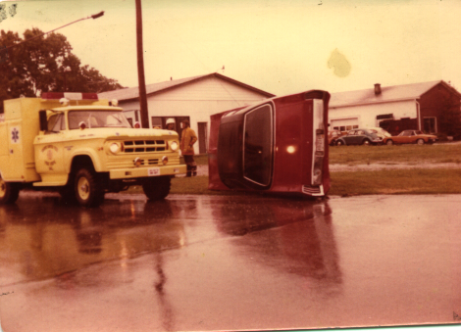
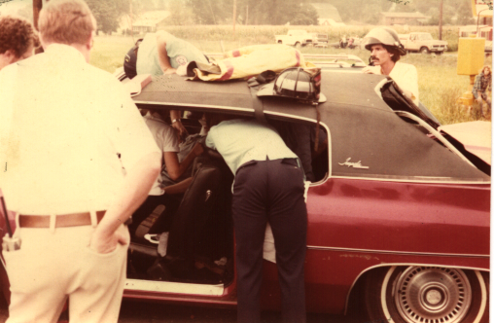

Answer to the parting pictures: In the first picture, the car is on it’s side. The next picture shows the car on it’s wheels and the firefighters removing a patient. Do you suppose they thought it would be easier to get the patient out if the car was level?

That’s all. See you same place next month. Stay safe. -Scott

